**Task on Angular Forms**

**Create Angular components to create vehicle Registration Form. Implement the following validations using Angular forms concept --- model driven**

1. Owner Name --- Required  
2. Contact Number ---- Required , should contain 10 digits  
3. Owner Email --- Required, Email  
3. Vehicle Registration Number ---- Should be proper format --- (Eg: TS10AB1234)  
4. Address : Required  
5. Model : 10 characters  
6. Color : Required   
7. Year : 2012 to 2022

**Output**

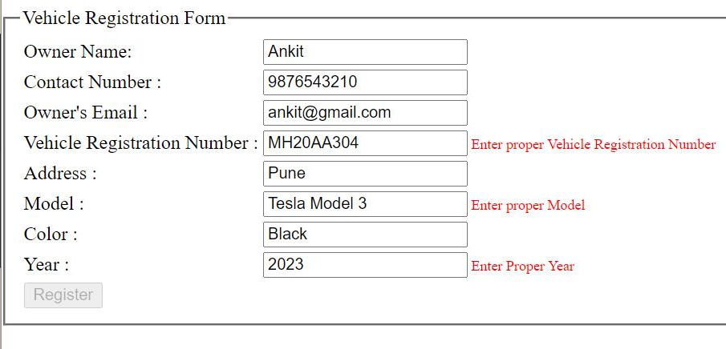

**Component TS File**

